Scope of WORK

Procurement shared services Portal

Group DIGITAL & TECHNOLOGY
www.al-ghurair.com

DOCUMENT CONTROL:
DOCUMENT ID | SOW_PSSC_Phase2_V1.0
DOCUMENT NAME | SCOPE OF WORK: PROCUREMENT SHARED SERVICES PORTAL
Version | V1.0

Disclaimer:
Confidentiality and Ownership
This Statement of Work (SOW) is both confidential and proprietary to Al Ghurair, which reserves the right to recall the SOW in its entirety or in part. The vendor shall not duplicate, distribute, disseminate, or make this document or the information contained herein available to any party without the written consent of Al Ghurair.
The vendor may share this document only with employees who have a legitimate need to know its contents in order to participate in the preparation of a response. However, the vendor must first communicate the terms and conditions of this section to such employees.
The vendor shall not reference or include this SOW in any publicity without prior written approval from Al Ghurair. All responses to this SOW will become the property of Al Ghurair and will not be returned.
Should you choose not to participate, please destroy this SOW package.
Unless otherwise agreed in writing by Al Ghurair, the company shall be entitled to retain and use any information submitted by vendors in relation to this SOW, including quotations, regardless of whether the vendor is awarded the project.
Liabilities
This SOW does not constitute an offer by Al Ghurair, but an invitation for Vendor response. No contractual obligation whatsoever shall arise from the SOW process.
Modification/Termination of SOW
Al Ghurair reserves the right, at its sole discretion, at any time to: (i) accept or decline any and all Proposals/ Quotations from Vendors without any explanation and whether or not such Proposal /Quotation(s) contains the most favourable fee or fully satisfies the express requirements; and (ii) terminate the proposed project or the vendor selection process without notice and/or explanation, without in either case incurring any liability to the vendors and/or any other third parties.
Expenses Incurred
All expenses for development of quotation/ proposal and participation in the SOW, including site visits, document preparation, communications, and demonstrations, are entirely the responsibility of the vendor and will not be chargeable to Al Ghurair. The rejection of any or all proposals, or the termination of the SOW at any time, shall not render liable for any reason.
Table of Contents
1. SECTION A: INTRODUCTORY INFORMATION 4
1.1 INTRODUCTION 4
1.2 COMPANY BACKGROUND 4
2. SECTION B: SCOPE 5
2.0 General Information form 5
2.1 Scrap Sales & De-fleeting of vehicles (Non-Kabi) 6
2.1.1 Disposal Request Form (Form 1) (From BU to PSSC) 6
2.1.2 Scrap Vendor Sourcing (Form 2) (From PSSC to vendors) 8
2.1.3 PSSC Status update form (Form 3) (From PSSC to Requestor) 10
2.1.4 BU response form (Form 4) (For Requestor) 13
2.1.5 Selected Vendor/Revenue update form (Form 5) (For Requestor) 14
2.1.6 Dashboard - Requirements 15
2.1.7 Current Challenges 15
2.1.8 Benefits 15
2.1.9 Automation Opportunities 16
2.2 LTPA Creation/Amendment/Renewal for Xpedeon 17
2.2.1 Request form for LTPA Creation/Amendment/Renewal 17
2.2.2 Response form 18
2.2.3 Dashboard - Requirements 18
2.2.4 Current Challenges 18
2.2.5 Benefits 18
2.2.6 Automation opportunities 18
2.3 Insurance Sourcing Request 19
2.3.1 Insurance Sourcing Request Form(Form 1) (From Requestor to PSSC) 19
2.3.1.1 Group Insurance consolidation form(form1.1) (for all group policy requests) 22
2.3.2 Insurance Vendor Sourcing Form (Form 2) (From PSSC to vendors) 22
2.3.3 Status Update Form (Form 3) (From PSSC to Requestor) 24
2.3.4 Dashboard - Requirements 26
2.3.5 Current Challenges 27
2.3.6 Benefits 27
2.3.7 Automation opportunities 27
2.4 External Hire Request 28
2.4.1 External Hire Request Form(Form1) (From Requestor to PSSC) 28
2.4.2 External Hire Vendor Sourcing(Form 2) (From PSSC to vendors) 29
2.4.3 Response Form(Form 3) (From PSSC to Requestor) 31
2.4.4 Dashboard - Requirements 33
2.4.5 Current Challenges 33
2.4.6 Benefits 34
2.4.7 Automation opportunities 34
2.5 Exceptional Approval Request (From PSSC via existing forms in the portal) 34
2.5.1 Exception approval request form 35
2.5.2 Current Challenges 36
2.5.3 Benefits 36
2.5.4 Automation opportunities 36
2.6 Chatbot 36
2.7 Landing page of PSSC team(will have requests of PSSC and UVP) 37
2.8 Common approval process for PSSC and UVP 38
2.9 Team assignment for the first time login 38
2.10 SLA Matrix 38
3. SECTION C: SOW REQUIREMENTS 39
3.1 Project Plan: 39
3.2 Team Composition: 39
3.3 RACI Matrix: 39
3.4 Pricing: 39
3.5 Payment Terms: 39
4. SECTION D: SIGNATORIES 40
40

SECTION A: INTRODUCTORY INFORMATION

1.1 INTRODUCTION
Al Ghurair wanted work to be delivered for an initiative aimed to create a Procurement shared service portal with an emphasis on streamlining the process between BU Procurement and Procurement shared services.

Project Objectives:
- Enhance the existing PSSC portal built during the MVP phase by introducing additional procurement processes, workflows, and functional capabilities based on business feedback and usage data.
- Integrate newly identified scope areas such as Savings Initiative Tracking, Scrap Disposal Requests, LTPA creation and Chatbot into the portal to streamline Procurement shared service operations.

1.2 COMPANY BACKGROUND
Al Ghurair, a distinguished and dynamic conglomerate, stands as one of the largest and most renowned diversified industrial enterprises in the Middle East. With an illustrious legacy that spans over five decades, the Al Ghurair name is synonymous with the United Arab Emirates, reflecting our deep-rooted connection to the region.
Driven by our commitment to excellence, trust, and social responsibility, we have consistently pioneered innovative businesses that contribute to the enhancing the lives of the communities we serve. Our core areas of focus include Foods, Construction, Resources, and Properties, where we have achieved remarkable success. Additionally, we actively participate in sectors such as Energy, Automotive, Printing, Retail, Kabi, and Education, further highlighting our commitment to diverse engagement in both B2B and B2C realms.

SECTION B: SCOPE
The selected vendor will be expected to deliver following requests as part of the solution delivery.

2.0 General Information form

(General form is available in the portal the provided request types to added)

General Info
Request reference number* | Auto generated
Request raised on behalf of | Dropdown of team members to be captured from system
Request type* | Scrap Sales and De-fleeting(Non-Kabi)
Sub Request type* | Dropdown
Priority* | Auto select P1

Dropdowns
- Request type: Scrap sales and De-fleeting (Non-Kabi) request
Forms :
- Disposal Request Form
Sub request types:
  - Scrap
  - Asset
  - Surplus
  - De-fleeting (Non-Kabi)
- Vendor Sourcing Form
- Status Update Form
- BU Response Form
- Selected vendor- Revenue update form

- Request type: LTPA - Xpedeon
Sub request types:
- LTPA Creation
- LTPA Amendment
- LTPA Renewal

- Request type: Insurance Sourcing Request
Forms:
- Insurance Sourcing Request Form
- Group Policy Consolidation Form
- Vendor Sourcing Form
- Status Update Form

- Request type: External Hire Request Form

Forms:
- External Hire Request Form
- Vendor Sourcing
- Status Update

- Request type: Exceptional Approval Request
Forms:
- Exceptional Approval Request Form

2.1

Scrap Sales & De-fleeting of vehicles (Non-Kabi)

As-Is Process:

To be high level process:
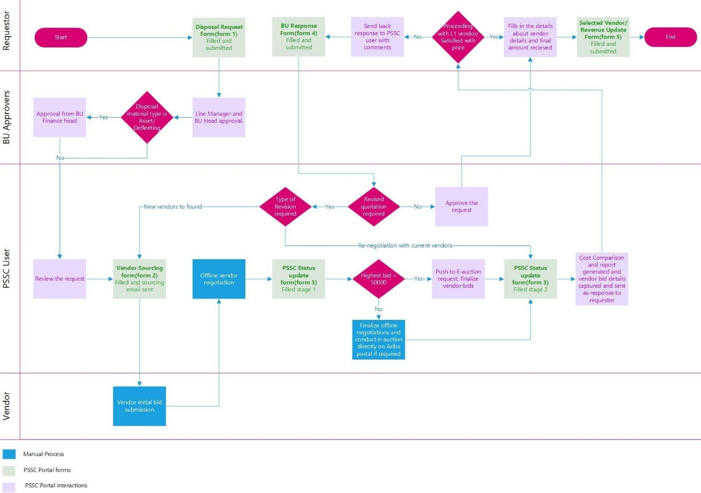

To-be Process:

2.1.1 Disposal Request Form (Form 1) (From BU to PSSC)

Digital Form
Disposal Request Form (DRF)
Business unit * | Drop down | Dropdown BU list from D365
Legal Entity * | Drop down | Dropdown of all legal entities from D365
DRF Ref no * | Auto generated by system | Should be greyed out in case of auto generated number
Memo Ref no | Manual input | Alphanumeric field
NCR no | Manual input | Alphanumeric field
Request details* | Manual input | Alphanumeric field - Character limit to be set to 1500 characters, Mention request details
Disposal material type* | Dropdown option | Mandatory selection  - Scrap  - Asset  - Surplus  - De-fleeting(Non-Kabi)
Material Details* | (User can "Add Row" to input multiple materials.) | If Disposal Material Type = Scrap/Asset/Surplus  This part can be a dynamic table where user adds rows (Should be mandatory for all Disposal material type other than De-fleeting)
SI No. | Item / Material Description | Reason for Disposal | Weight (kg) | Asset (Yes/No) | Asset code in system | Original Cost (AED) | Selling Cost (AED)
Expected Sale Value (in AED) * | Manual input | Numeric field
Allocated Marketing expense (in AED) * | Manual input | Numeric field
Vehicle Details* | (User can "Add Row" to input multiple vehicle details.) | If Disposal Material Type = De-fleeting  This part can be a dynamic table where user adds rows (Should be mandatory if Disposal material type is De-fleeting)
SI No. | Registration No | Make | Type | Manufacturing Year | Chassis No | Engine No | Purchase Value | Acc Depreciation | NBV | Justification
Memo copy | Attachment | Option to attach file
Annexure copy | Attachment | Option to attach file
Other documents | Attachment | Option to attach multiple files
Photos of materials* | Attachment | Option to attach multiple files
Material location* | Manual input | Text field Maximum character limit of 100
Name & contact details of store in charge* | Manual input | Text field Maximum character limit of 100

DoA(Disposal required material selected is Scrap/Surplus)

A | B | C/Review and allotting | Review and allotting
Line manager/BU Manager | BU Head/HOD | Procurement Manager/SVP | PSSC

DoA(Disposal required material selected is Asset/De-fleeting)
A | B | C | D/Review and allotting | E/Review and allotting
Line manager/BU Manager | BU Head/HOD | Head of Finance | Procurement Manager/SVP | PSSC

Notes:
- An email containing the request details and attachments shall be automatically generated and sent to the BU Approver and the PSSC SPOC.
- The BU Manager should have the option to return the request to the originator or reject it entirely (complete rejection).
- The request can be returned to the originator with comments by the PSSC user if additional input or corrections are needed.

- Default DoA as defined in the form to be set for all users across BU’s
- Upon approval as per the DoA, the vendor sourcing form shall be automatically initiated in the portal and assigned to the PSSC team.
2.1.2

Scrap Vendor Sourcing (Form 2) (From PSSC to vendors)

Digital Form
Vendor Sourcing Form
DRF Ref no | Dropdown from portal database with option to select from open requests assigned to PSSC | Details to be fetched from DRF form (Disposal Request Form)
Disposal material type* | Auto populated from DRF form
Request Type: * | Dropdown | - Inquiry for Quotation  - Site Visit Request
Material Details/Vehicle details* | Auto populate from DRF form | IF Disposal Material Type = "Scrap" OR "Asset" OR "Surplus"  → Fetch and display "Material Details" table from DRF form  ELSE IF Disposal Material Type = "De-fleeting"  → Fetch and display "Vehicle Details" table from DRF form  Option to edit to be given  • PSSC user should be able to select/assign vendors for each line item in the is auto populated material/vehicle details table as a new column  • System should be able to fetch all the items selected for each vendor and then send consolidated mail capturing all requirements from a specific vendor
Photos of Materials * | Auto populate from DRF form | Mandatory, Option edit or add more photos to be given
Name and contact of in-charge* | Auto populate from DRF form | Option to edit to be given
Location of the material | Auto populate from DRF form | Option to edit to be given
Preferred Quotation Due Date: * | Dropdown - Calendar | Mandatory
Vendor details |  | "Add new vendor button"
Vendor Name* | Dropdown (Allow multiple inputs) | Mandatory, Fetch vendor data from D365
Vendor Contact Person | Autopopulated | With option to update/edit
Vendor Contact Email | Autopopulated | With option to update/edit
Vendor Contact Number | Autopopulated | With option to update/edit
Email Subject * | Text field | Default Template: "Request for Quotation/Pickup - [Material Type]" with option to edit
Email Body * | Text area (Rich text) | Auto-filled basic template + allow user to modify before sending, with option to edit
Default Email Body Template: | Dear [Vendor Contact Person],  We request your quotation/site visit for the following materials marked for Disposal/Sale:  Type of Material: [Scrap/Surplus/Asset/Vehicle]  Material detail:  [SI No. | Item / Material Description | Weight (kg) | Original Cost (AED) | Selling Cost (AED)]  Or  Vehicle details  [SI No. | Registration No | Make | Type | Manufacturing Year]  Location: [Material Location]  Kindly find attached supporting documents. Please revert by [Preferred Quotation Due Date].  Regards,  [PSSC Team Contact]  [PSSC Email ID] | Fetch {Vendor Contact Person}, {Type of Material}, [Material Location], [PSSC Team Contact], [PSSC Email ID]  Option to edit mail body to be possible  This should be dynamic based on “Request type” field selection, with option to edit and option to update template.
Attachments (Auto-attached to email) | Dropdown to fetch attached images and documents from Disposal request form, with option to select multiple files | Option to primarily attach the images uploaded on the request form by the user and to select any documents like annexure copy required to be shared to vendors which is attached to the DRF request form submitted by user

Executioner
A | B | C
PSSC

Notes:
- PSSC user can assign/select vendors for each line item in the auto-populated material/vehicle details table via a new column.
- System fetches items tagged to each vendor and sends a consolidated email with all requirements per vendor.
- Email is auto-generated with relevant attachments and sent to the selected vendors.
- Portal auto-updates the status from "Approved" to "Vendor Communication Sent".
- Email notification capturing change in status to “Vendor Communication Sent” is sent to the BU requestor post the submission of form 2 by the PSSC user.
- "Add Vendor" button to be included for selecting additional vendors from the registered D365 database.
- Upon email dispatch, a new form is created, status auto-updated, and assigned to PSSC under the same reference number; action is logged for traceability.
- The entire process will be handled by the same PSSC team member.

2.1.3

PSSC Status update form (Form 3) (From PSSC to Requestor)

Digital Form
PSSC Status update Form
DRF Ref no* | Dropdown with Search |  | Based on input details to be fetched from Disposal Request form
Date of last update: * | Auto-filled Today's Date
Request Status
Current Request Status* | Status to be updated by the system as per the current stage of the form |  | Request Status  - Vendor Sourcing floated  - Negotiation and Quote finalization  - Cost Comparison  - Completed
Stage 1
Bid Summary
No. of Vendor Bids Received* | Number Field
Currency* | Dropdown of currencies in D365
Highest bid received post negotiations* | Number Field
DoA for Pushing request to E-auction/Create e-auction request and Exceptional Approval Request Form

If Highest bid received post negotiations >= 50,000 option to initiate request form for E-auction form and exceptional approval form should appear
If the condition is met:
PSSC user sees the following options on screen:

Option | Condition | Action
Create / Redirect to E-Auction Request Form | If Highest bid received post negotiations >= 50,000 and E-auction is conducted | Button to create a new E-Auction form (pre-filled from DRF), OR push existing request into E-Auction flow
Create Exceptional Approval Request Form | If Highest bid received post negotiations >= 50,000 and E-auction not being conducted | Button to raise an Exceptional Approval form (linked to DRF) explaining justification for bypassing e-auction

Stage 2
CC Reference Number* | Auto generated |  | System-generated unique ID (read-only)
Request Reference Number* | Auto populated from DRF number
E-auction reference number | To be auto captured from the e-auction request generated in stage 1 or entered manually if not possible |  | Mandatory if Highest bid received post negotiations >= 50,000 and e-auction is conducted
Exceptional approval reference number | To be auto captured from the Exceptional approval request generated in stage 1 or entered manually if not possible |  | Mandatory if Highest bid received post negotiations >= 50,000 and e-auction is not conducted
Business | Auto populate from DRF form
No. of Vendor Bids Received | Auto populate from stage 1
Cost Comparison Table* | (Dynamic Grid Table) Option to add vendor details as columns and items as rows |  | Sample output of Cost Comparison Generated  Reference table for design -
SI# | Item | Category |Description | Qty | UOM | Historic Rate | Total Amount | Vendor Name 1 (Initial Rate/bid | Initial Amt/bid | Disc Amt| Amt after Disc/Negotiation | Rate after E-auction| Amount after E-auction| Final rate| Final amount | Delivery date| Quote attachment
Item 1
L1 Vendor Name* |  | Auto populated based on user input in Cost comparison |  | L1 vendor corresponds to vendor with highest value final bid after Cost comparison creation
L1 Vendor Rate* |  | Auto populated based on user input in Cost comparison |  | L1 vendor corresponds to vendor with highest value final bid after Cost comparison creation
Customer SPOC Contact Details* |  | Alphanumeric field

DoA
A | B | C
PSSC | SVP – Procurement/Head of PSSC (Approval only after stage 2)

Notes:
- Once this form is created following the submission of the vendor sourcing form, its status should be set to "Vendor Sourcing Floated."
- Upon completion of Stage 1, the form status should update to "Negotiation and Quote Finalization."
- Following Stage 1, the PSSC user should have the option to initiate a new e-auction request on the portal—either by redirecting to an e-auction if the highest bid meets the DoA threshold or by pushing the existing request to an e-auction form.
- If an e-auction is not conducted despite meeting the threshold, the PSSC user should have the option to proceed to the Exceptional Approval Request form.

- Upon completion of Stage 2, the form status should be updated to "Cost Comparison Creation."
- Cost comparison to be generated in the same format as the attached file.
- Post stage 2 cost comparison document to be generated by the system with the details submitted by the user which will be sent to SVP as per DoA for approval of CC. Post approval the status changes to completed and sent to the requestor.
- In case CC is rejected by the DoA the form to be sent back to PSSC user for re-negotiation and getting new bids.
- All attachments in the form made by PSSC to be visible to the requestor in the form of a final report which must be send as an attachment in the automated e-mail to the BU user.

- Auto-calculate SLA Days between DRF creation and Completed date for internal reporting.
- The PSSC Head/SVP will have the option to reject Form 3 with comments, allowing the PSSC user to renegotiate with vendors, update quote details and the cost comparison in Stage 2, revise the L1 vendor information, and resubmit the form for SVP approval before it proceeds to the BU requestor.
- If the BU approves the cost comparison and is proceeding with the L1 vendor shared by PSSC, the user can approve the submitted CC, and the request will move to Form 5.

2.1.4

BU response form (Form 4) (For Requestor)
Digital form for BU response form(form 4)

DRF Ref no | Auto populated from form 1
Request type* | Dropdown | Dropdowns:  - Proceeding with L2 vendor  - Proceeding with L3 vendor  - Proceeding with L4 vendor  - Proceeding with L5 vendor  - Proceeding with L6 vendor  - Others
Others* | Dropdown | Mandatory if request type is Others  Dropdowns:  - Re-negotiation required  - New vendors required
Reason for request* | Alphanumeric field
Send back option(button)

PSSC Response form from the PSSC user:
PSSC Response form for form 4(BU Response form)

DRF Ref no | Auto populated from form 1
Request type | Auto-populated from form 4
Others | Auto-populated from form 4
Buttons/Options to be available for PSSC user
- Approve button
- Send to form 2 |  | In cases where new vendors are required
- Send to form 3 |  | In cases where only re-negotiation is required
- Reject button

Notes:
- In case of L1 vendor rejection/L1 vendor unavailability/Preference for Non-L1 vendor/better prices needed etc the BU requestor will be having the option to send back a response form to PSSC user via form 4, otherwise the user will be allowed to proceed to form 5.
- The PSSC user will have the option to accept the request from the BU user and send the request to form 5 in case he requests type is going with L2-L6 vendor
- If the request type is "Re-negotiation", the request will return to Form 3 after PSSC user approval, allowing the user to renegotiate with vendors, update bid values, and generate a revised cost comparison following the same process flow and DoA.
- The PSSC user will also have the option to directly reject the request from the user.with comments
- Option to push request into e-auction reopening to be possible in case e-auction needs to be done again.
- If the request type is "New Vendor Required", it will return to Form 2, allowing the PSSC user to add new vendors to the mailing list, invite fresh bids, and proceed with the same process flow thereafter.

2.1.5

Selected Vendor/Revenue update form (Form 5) (For Requestor)
Digital form for Selected Vendor/Revenue update

DRF Ref no | Auto populated from form 1
Vendor name* | Dropdown | Vendor name selected from cost comparison
Currency* | Dropdown of currencies in D365
Final amount deposited* | Alphanumeric field

Notes:
- The system should send an automated email to the requestor after Form 3 is submitted, prompting them to provide the final update on the selected vendor post internal processes.
- A reminder email should be sent 5 days after Form 3 completion and every 2 days thereafter until Form 4 is submitted.
- Once the form is completed, the PSSC user should be notified via email, and the amount filled in the form should be captured in the dashboard.
- Once the form is completed the PSSC user to be notified by e-mail and the amount filled in the form to be captured in the dashboard
- An SOP has to be defined across all BUs by procurement team to follow the to be process in PSSC portal post go live of the solution

2.1.6

Dashboard - Requirements
- The dashboard should display the total number of requests versus their current status (Vendor Sourcing Floated, Negotiation and Quote Finalization, Cost Comparison).
- Stacked column charts should present monthly data on requests received, categorized by sub-request types and final bids.
- A line or area chart should reflect cumulative extra revenue generated through e-auctions compared to initial bids, based on data from the cost comparison table.
- Include an overview of the average number of days taken from initial request to process completion.
- A graph should show the split of material disposal types (Scrap, Asset De-fleeting, Surplus) against the total number of requests.
- Include a tracker for requests nearing SLA violations and those where SLAs were breached by staff.
- Track the volume of requests that proceeded to E-auction or required Exceptional Approval.
2.1.7

Current Challenges
- The current process is largely manual, relying on physical documentation and signatures.
- There is no centralized system for tracking incoming requests; instead, an Excel tracker is manually maintained by the procurement executive.
- Communication between requestors and procurement is handled via email, increasing the risk of missed or overlooked requests.
- Delays occur due to the need for multiple stakeholder signatures, with no SLA tracking in place.
- Cost comparisons and vendor details are shared through scanned copies or email attachments, with no centralized repository for monitoring.
- Stakeholders have limited visibility, and the process heavily depends on a single procurement executive managing end-to-end activities.
- There is minimal control over potential fraudulent activities after procurement involvement.
- Visibility and control over the P&L impact of the procurement process are limited
2.1.8

Benefits
- Standardization of the process across all BUs post-centralization, with an SOP to be developed and published.
- Improved visibility for all stakeholders across the end-to-end process.
- An estimated 16–22% reduction in time spent and 2–3 days shorter lead time based on TMS analysis of the current process, by eliminating intermediate email communications for data collection, approvals, and consolidation.
- Centralized request tracking and dashboard view showing request types, revenue generated, and SLA breaches.
- Semi-automated cost comparison creation and seamless redirection to e-auction or exceptional approval forms to ensure all sub-processes remain within the main workflow.
- Automated notifications to users and requestors on the current request status.
- SLA tracking to reduce delays and identify bottlenecks or areas needing improvement.
- Stronger control to prevent potential fraudulent activities.
- Better control and visibility over the P&L impact of the procurement process.
2.1.9

Automation Opportunities
- Building system capabilities to capture vendor bids even when e-auctions are not conducted.
- Exploring options to automate manual negotiation processes.
- Automating cost comparison creation directly from the quotations attached within the forms.
- Implementing smart form linking to pre-fill interconnected forms like E-auction or Exceptional Approval, reducing manual input.
- Developing a backend analytics module to generate periodic insights and exception reports.
- Creating a centralized folder system to store form-linked documents for future reference.

Sample UI/UX View for PSSC User:
- The following screen captures how the screen will look like for the PSSC user post receiving a request.
- 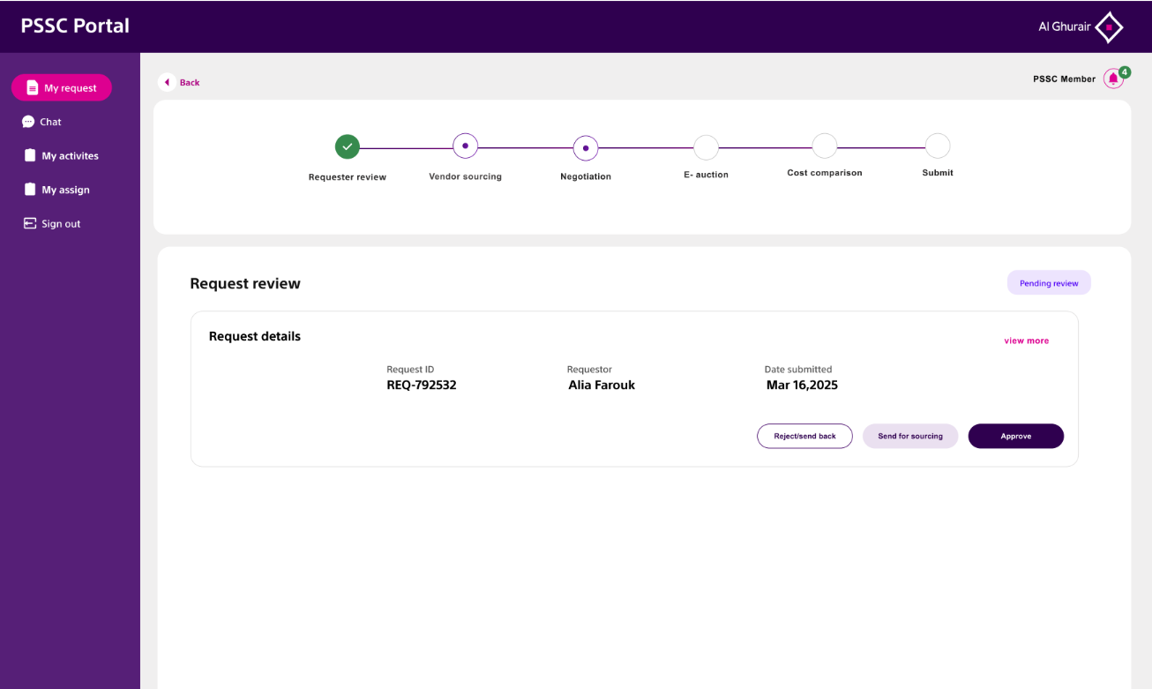

2.2 LTPA Creation/Amendment/Renewal for Xpedeon

As-Is Process:

To be process High level:

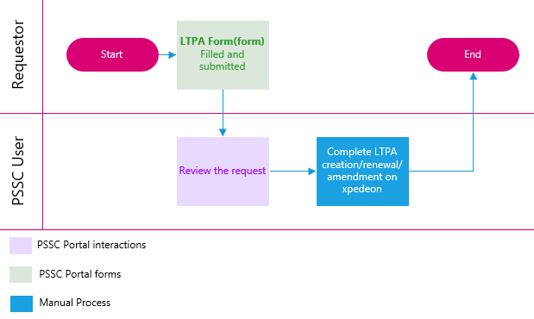
To-be Process detailed:

2.2.1

Request form for LTPA Creation/Amendment/Renewal

Digital form for LTPA creation/ amendment/renewal for Xpedeon

Action Type* | Drop down | - Creation  - Amendment  - Renewal
Legal Entity* | Drop down of all legal entities from D365 filtered for Xpedeon
Vendor code* | Number | Drop Down from D365 filtered for Xpedeon based on the legal entity selected
Vendor name* | Auto Populate | Auto Populated from vendor code
Release Entity (Select all where Purchase agreement to be created) * | Multiple selection to be allowed
Final quotation/contract* | Attachment
Item codes list/category code in excel* | Attachment
Additional attachments | Multiple attachments | Optional
Comments | Alphanumeric field | Optional

Notes:
- The PSSC team will retrieve relevant data from selected fields in the attached contract documents to complete the process on Xpedeon.

2.2.2 Response form
LTPA creation/ amendment/renewal for Xpedeon
Legal Entity | Multiple selection for legal entity | Mandatory
Closing Status* | Drop down | Completed, Failed
Comments | Text Field | Optional

DOA MATRIX
Request Type | DOA Required | Approval 1 | Approval 2 | Approval 3
LTPA Creation/ amendment/renewal | No (DoA already available in Xpedeon system)

2.2.3

Dashboard - Requirements
- The dashboard should show the total number of requests received, along with counts of open and completed requests.
- A tracker should monitor requests nearing SLA violations and those where SLAs have been breached by staff.
2.2.4

Current Challenges
- This backend process is currently handled by procurement front-end executives, diverting their time from value-added tasks.
- There is no centralized tracking for the existing LTPAs; instead, an Excel tracker is used.
2.2.5

Benefits
- The time spent by front-end executives in the current process is expected to reduce by 40–45%.
- PSSC users will be trained to create LTPAs on Xpedeon by extracting data from contracts submitted by requestors.
- The process is integrated with D365 entities, promoting standardization across the group.
- Improved visibility for all stakeholders with centralized tracking of requests.
- Automated notifications will keep users and requestors informed about request status.
- SLA tracking will help minimize delays and identify bottlenecks and areas for improvement.
2.2.6

Automation opportunities
- Building system capabilities to capture all necessary details for LTPA creation on Xpedeon directly from contracts.

- Creating an interlink between the PSSC portal and Xpedeon to auto-populate LTPA data from the portal into Xpedeon.

2.3 Insurance Sourcing Request

As-is process:
To-be process highlevel:
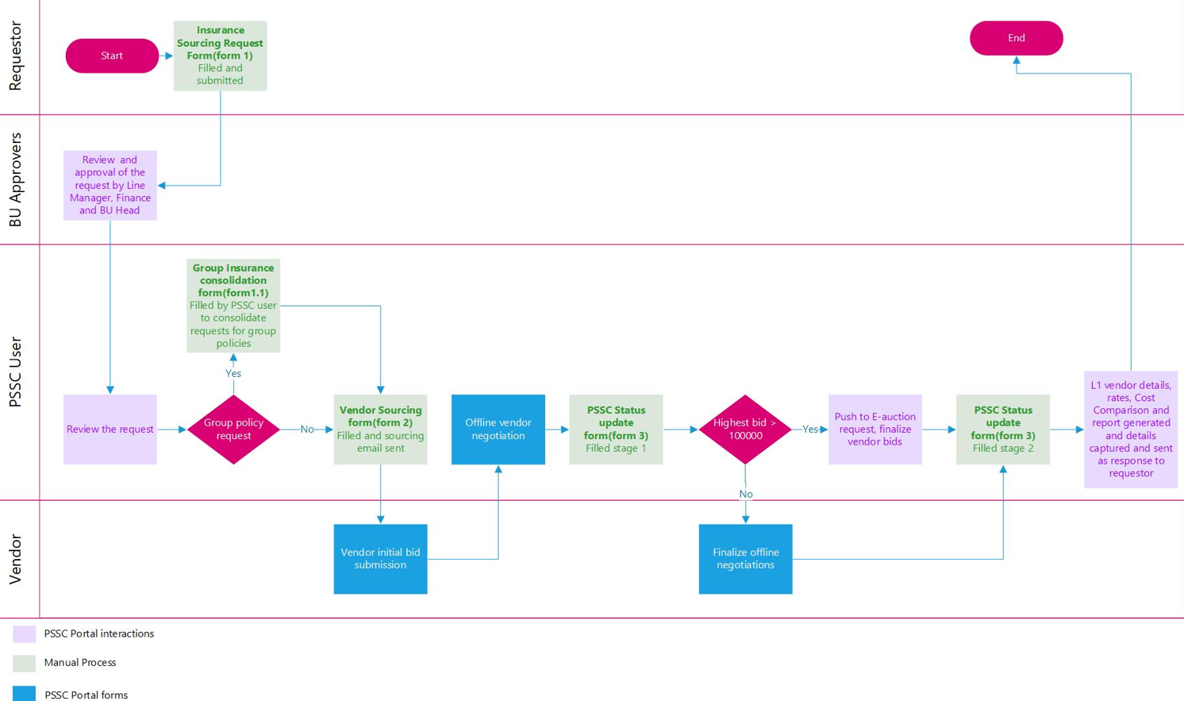

To-be process detailed:
When CLM would be live, the initiation would still start in the PSSC portal, once contract is created and signed, CLM will take over for contract lifecycle management

2.3.1

Insurance Sourcing Request Form(Form 1) (From Requestor to PSSC)
Digital Form from BU to PSSC
Request Reference Number: * | Auto Generated | System-generated unique ID (read-only)
Business* | Dropdown with option to select multiple options | List of BUs/Departments (fetched from D365 )
Legal Entity* | Dropdown | List of Legal Entities (fetched from D365 )
Request Details
Policy Requirement* | Dropdown | - Group Policy  - BU Specific Policy  - Project-Specific Policy
Type of Request* | Dropdown | - New  - Renewal  - Endorsement
Type of Insurance* | Dynamic Dropdown with Text Option | Group Policy Dropdowns (Policy Requirement= Group Policy)  - Medical Policy  - Staff Medical  - Group Life Insurance  - Personal Accident  - GLPA (Group Life & Personal Accident)  - Workmen Compensation & Employer's Liability(WC/EL)  - Public Liability  - General Third Party Liability / Public Policy  - TPL (Third Party Liability)  - Group Motor Fleet  - Motor Policy  - Airside Liability  - International Terrorism  - Trade Credit  - Money  - Fidelity Guarantee  - Commercial Crime  - Other(Text input)  BU Specific and Project Specific Policies Dropdowns(Policy Requirement = BU Specific/Project Specific Policy)  - Contractors All Risk Policy (CAR)  - Erection All Risk (EAR)  - CPM (Contractor Plant & Machinery)  - Plant and Equipment Insurance  - Fire Policy  - Fire and Burglary  - Property All Risk Insurance(PAR)  - Industrial All Risk  - Electronic  - Machinery All Risk  - MOC (Machinery Operational Cover)  - Motor Test Plate  - Taxi Fleet  - Goods in Transit  - Marine  - Poultry  - Other(Text input)
Policy Number | Alphanumeric field | To be made mandatory if the Type of Request is renewal
Period of Insurance* | Date range picker | Start Date – End Date
Currency | Dropdown | Dropdown of existing currencies on D365
Sum Insured / Project Value* | Manual input(numeric) | Numeric field
Brief Description of request* | Manual input | Text field (limit: 500 characters)
Attachments* | (File Upload-multiple files) | Upload: Scope of Work, Questionnaire, Contract Conditions, Project Timeline and any necessary files  Preview file option
Urgency of Request* | Dropdown | - Routine  - Urgent  - For Client Submission
Exceptional Conditions | Alphanumeric field | To highlight any specific or exceptional requirements
Requested by (Name & Contact) * | Alphanumeric field

DoA
A | B | C
Line manager/BU Manager | Finance approval | BU Head/HOD

Notes:
- Once approved by all DoA levels, the form should proceed to the vendor sourcing form for BU-specific and project-specific policy requirements.
- Requests under Group policies will have an intermediate form (Form 1.1) to consolidate all requests for a common vendor sourcing email to the PSSC user after initial DoA approvals.
- An email with request details and attachments will be auto-generated and sent to the BU approver and the PSSC SPOC.
- The BU Manager will have the option to return the request to the requestor with a complete rejection.
- The PSSC team can return the request to the requestor with comments if needed.
- Policy templates to be available on the form for the BU user:
  - Option 1- Provide a shared folder link within the form for users to download the templates as per the policy type and a pop up notifying the users all the documents that are mandatory for the policy type has to be shown by the system based on the “Type of Insurance” selection.
  - Option 2- All templates for the different insurance types to be incorporated in the system with system fetching the template fields based on the “Type of Insurance” selection.

2.3.1.1 Group

Insurance consolidation form(form1.1) (for all group policy requests)
Digital Form for PSSC to consolidate multiple requirements coming for group policy
Request Reference Number: * | Autopopulated | System-generated unique ID (read-only)
Policy master type* | Dropdown | Dropdown of all group policy requirements
Member requests* | Dropdown with option for multiple selection | (Will also list down all requests currently grouped under policy master type)
Total value | Autocalculated by the system | Total value = Total of sum insured/project value for all request that comes in a group request
Description | Alphanumeric field

Notes:
- PSSC user will assign a policy master type to all requests based on the group policy type for consolidation.
- For all group-level requests grouped under one policy master type, a single vendor sourcing form (Form 2) and status update form (Form 3) will be created after all requests are submitted.
- PSSC user will have the option to access Form 1.1 directly as the next step after Form 1

2.3.2 Insurance Vendor Sourcing Form (Form 2) (From PSSC to vendors)

Digital Form
Vendor Sourcing Form
Insurance Req Reference No | Dropdown from portal database with option to select from open requests assigned to PSSC | Details to be fetched from Insurance Request Form
Type of request * | Auto populate from insurance request form
Policy requirement* | Auto populate from insurance request form
Type of insurance* | Auto populate from insurance request form
Period of Insurance* | Auto populate from insurance request form | PSSC user to have option to edit total sum insured in case of group policy requirement
Sum Insured / Project Value* | Auto populate from insurance request form/ in case of group policy auto populate from consolidation form | PSSC user to have option to edit total sum insured in case of group policy requirement
Brief Description of request* | Auto populate from insurance request form/in case of group policy auto populate from consolidation form | PSSC user to have option to edit total sum insured in case of group policy requirement
Preferred Quotation Due Date: * | Dropdown - Calendar
Vendor details |  | "Add new vendor button"
Vendor Name* | Dropdown (Allow multiple inputs) | Preloaded vendor data should be fetched from D365
Vendor Contact Person | Autopopulated | With option to update/edit
Vendor Contact Email | Autopopulated | With option to update/edit
Vendor Contact Number | Autopopulated | With option to update/edit
Email Subject * | Text field | Default: "Insurance Quotation Request – [Type of Insurance]", editable
Email Body * | Text field | (Editable) Auto-filled basic template + allow user to modify before sending, with option to edit
Default Email Body Template: | Dear [Vendor Contact Person],  We are requesting your quotation for the below insurance requirement as per the details shared by the Business Unit:  Policy Requirement: [Group / BU-specific / Project-specific]  Type of Insurance: [e.g., CAR / PI / Group Medical / Other]  Type of Request: [New / Renewal / Endorsement]  Insurance Period: [Start Date] to [End Date] from [Insurance Period]  Sum Insured / Project Value: [Sum Insured / Project Value]  Brief Description:  [Brief Description of request]  Attached are the supporting documents including scope of work, contractual terms, timelines, and questionnaires.  We would appreciate receiving your quote by [Preferred Quotation Due Date].  Best regards,  [PSSC Team Contact]  [PSSC Email ID] | Option to update and save template and to select different fields within the mail or subject body to be possible  Option to edit mail body to be possible
Attachments (Auto-attached to email) | Dropdown of attached documents in insurance request form to select and attach documents with option to attach additional attachments | Option to primarily attach the documents like questionnaire, project details etc uploaded on the request form by the user

Executioner
A | B | C
PSSC

Notes:
- Email is auto generated with attachments and sent to the selected vendors.
- Email notification is sent to the PSSC requestor's email (optional).
- Portal auto-updates status: From "Approved" to "Vendor Communication Sent"
- Add vendor button to be included to add more vendors from the already registered vendor database in D365
- Once an email is sent to vendors, a new status update form(form 3) to be created, status to be updated, and new form to be assigned to PSSC under the same reference number, with the action logged for traceability

2.3.3 Status Update Form (Form 3) (From PSSC to Requestor)

Digital Form PSSC Status update Form
Insurance Request Ref no* |  | Dropdown with search |  | Details to be fetched from Insurance Request form
Date of last update: * |  | Auto-filled Today's Date
Request Status
Current Request Status* |  | Status to be updated by the system as per the current stage of the form |  | Request Status  - Vendor Sourcing floated  - Negotiation and Quote finalization  - Cost Comparison  - Completed
Stage 1
Bid Summary
No. of Vendor Bids Received* |  | Number Field
Lowest bid received post negotiations* |  | Number Field
DoA for Pushing request to E-auction/Create e-auction request and Exceptional Approval Request Form

If Highest bid received post negotiations >= 100,000 option to initiate request form for E-auction form and exceptional approval form should appear
If the condition is met:
PSSC user sees the following options on screen:

Option | Condition | Action
Create / Redirect to E-Auction Request Form | If Highest bid received post negotiations >= 100,000 and E-auction is conducted | Button to create a new E-Auction form (pre-filled from Insurance sourcing request form), OR push existing request into E-Auction flow
Create Exceptional Approval Request Form | If Highest bid received post negotiations >= 100,000 and E-auction not being conducted | Button to raise an Exceptional Approval form (linked to Insurance Sourcing request form) explaining justification for bypassing e-auction

Stage 2
CC Reference Number* |  | Auto generated |  | System-generated unique ID (read-only)
Request Reference Number* |  | Auto populated from Insurance Request reference number
E-auction reference number |  | To be auto captured from the e-auction request generated in stage 1 or entered manually if not possible |  | Mandatory if Lowest bid received post negotiations >= 100,000 and e-auction is conducted
Exceptional approval reference number |  | To be auto captured from the Exceptional approval request generated in stage 1 or entered manually if not possible |  | Mandatory if Lowest bid received post negotiations >= 100,000 and e-auction is not conducted
Business |  | Auto populated from Insurance Sourcing Request form
No. of Vendor Bids Received |  | Auto populated from stage 1
Cost Comparison Table* |  | (Dynamic Grid Table) Option to add vendor details as columns and items as rows |  | Reference table :
SI# | Item | Category |Description | Qty | UOM | Historic Rate | Total Amount | Vendor Name 1 (Initial Rate/bid | Initial Amt/bid | Disc Amt| Amt after Disc/Negotiation | Amount after E-auction| Final rate | Delivery date| Quote attachment
Item 1
L1 Vendor Name* |  |  | Auto populated based on user input in Cost comparison |  | L1 vendor corresponds to vendor with lowest value final bid after Cost comparison creation
L1 Vendor Rate* |  |  | Auto populated based on user input in Cost comparison |  | L1 vendor corresponds to vendor with lowest value final bid after Cost comparison creation
Customer SPOC Contact Details* |  |  | Alphanumeric field
L1 Vendor Rate* |  |  |  |  |  | Auto populated based on user input in Cost comparison | L1 vendor corresponds to vendor with highest value final bid after Cost comparison creation
Customer SPOC Contact Details* | Alphanumeric field

DoA*
A | B | C
PSSC | SVP Procurement (In case Total Sum Insured / Project Value >100,000)

Notes:
- When this form is created after the vendor sourcing form is submitted, its status should be set to "Vendor Sourcing Floated."
- Upon completion of Stage 1, the status changes to "Negotiation and Quote Finalization."
- After Stage 1, the PSSC user can initiate an e-auction by either redirecting to a new e-auction request if the lowest bid meets the DoA threshold or by pushing the existing request to an e-auction form.
- When Stage 2 is completed, the status updates to "Cost Comparison Creation."
- The system generates a cost comparison document from user-submitted details, which is sent to the SVP for DoA approval. After approval, the status changes to "Completed" and the document is sent to the requestor.
- If the cost comparison is rejected by the DoA, the form returns to the PSSC user for renegotiation and new bids in form 3.
- All attachments added by PSSC will be visible to the requestor as part of a final report, which is attached to the automated email sent to the BU user.
- The system will auto-calculate SLA days between insurance sourcing form creation and completion for internal reporting.
- Auto-calculate SLA Days between insurance sourcing form creation and Completed date for internal reporting.
- Option to update DoA to be given for future changes

2.3.4 Dashboard - Requirements
- The dashboard should display the total number of requests grouped by status: open, Vendor Sourcing Floated, Negotiation and Quote Finalization, and Cost Comparison.
- Monthly graphs should show the number of requests received.
- An overview of the average number of days from initial request to process completion should be provided.
- A graph should illustrate the distribution of different insurance types requested.
- Track requests approaching SLA violations.
- Track SLA violations by staff.
- Show the volume of requests that proceeded to e-auction.
2.3.5

Current Challenges
- The current process is mostly manual, with requestors sending vendor sourcing requests via email based on project or BU requirements.
- There is no centralized repository to track group policies or BU/project-specific requests; instead, an Excel tracker is manually maintained by the procurement executive or category manager.
- Communication between requestors and procurement occurs through email, increasing the risk of missed requests.
- Delays happen due to the need for multiple stakeholder signatures or email approvals, with no SLA tracking in place.
- Cost comparisons and vendor details are shared as Excel files or scanned copies via email, lacking a centralized tracking system nor centralised repository.
- Stakeholders have limited visibility into incoming requests, and the process heavily depends on one or two key resources managing it end-to-end.
- the process is majorly manual, with requestors sending mail requests for vendor sourcing based on project or BU level requirements
2.3.6

Benefits
- A potential 16–18% reduction in time spent is expected (excluding CLM implementation for renewal notifications) by eliminating initial and intermediate email communications with BUs for data collection, approvals, and consolidation.
- Standardization of the process across all involved BUs after centralization.
- Improved visibility for all stakeholders throughout the process.
- Centralized tracking of requests with a dashboard showing request types and SLA breaches.
- Automated cost comparison creation and redirection to e-auction or exceptional approval forms, keeping subprocesses within the main workflow.
- Automated notifications to users and requestors about request status.
- SLA tracking to reduce delays and identify bottlenecks and improvement areas.
2.3.7

Automation opportunities
- Building system capabilities to capture vendor bids beyond quotes submitted when e-auctions are not conducted.
- Automating cost comparison creation within forms directly from attached quotations.
- Implementing smart form linking to pre-fill interconnected forms like e-auction and exception approval, reducing manual input.
- Syncing submitted amount and vendor details to dashboard metrics automatically.
- Developing a backend analytics module for periodic insights and exception reporting.
- Creating a centralized folder system to store main form-linked documents for future reference.

2.4

External Hire Request

As-is process:
To-be process(High-level):
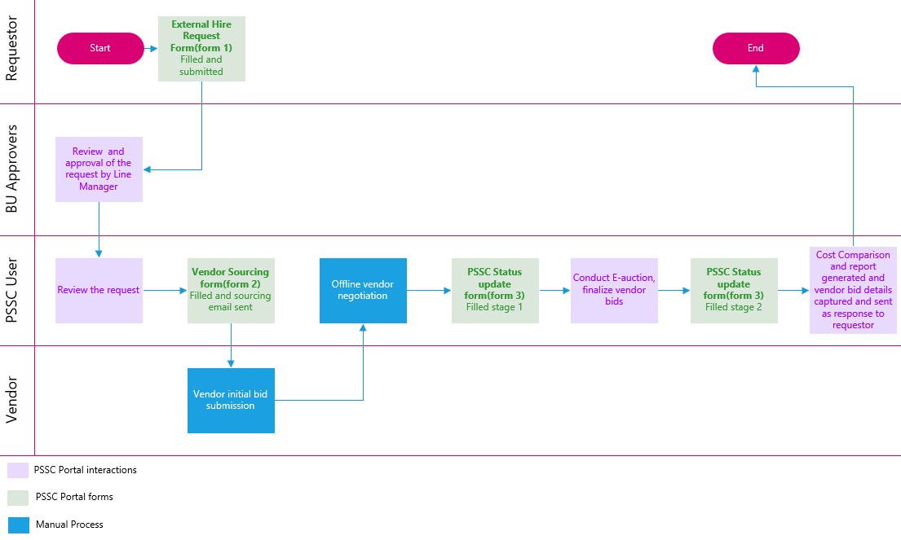
To-be process detailed:

2.4.1 External Hire Request Form(Form1) (From Requestor to PSSC)

External Hire Form Digital Form from BU/PSSC
Request Reference Number: * | Auto Generated | System-generated unique ID (read-only)
Business* | Dropdown | List of BUs/Departments (fetched from D365)
Legal Entity* | Dropdown | List of Legal Entities (fetched from D365 )
Project* | Alphanumeric field
Contact Name* | Text field
Mob No | Alphanumeric field
Fleet/Equipment Details* | (User can "Add Row" to input multiple vehicle details.) | This part can be a dynamic table where user adds rows  The requestor should be able to select “from date” only 3 days from the date of creation of form 1 by default
SI No. | Fleet/Equipment Name | Req Nos | From date | To date | Remarks
Specific reasons fleet/equipment required for: * | Alphanumeric field
DoA*
A | B | C
Line Manager/Project Manager(BU)

Notes:
- Once approved by all DoA levels, the form should proceed to the vendor sourcing form.
- An email with request details and attachments will be auto-generated and sent to the BU approver and the PSSC SPOC.
- The BU Manager will have the option to return the request to the requestor with a complete rejection.
- The PSSC user will have the option to return the request to the requestor with comments.

2.4.2 External Hire Vendor Sourcing(Form 2) (From PSSC to vendors)

Digital Form
Vendor Sourcing Form
Req Reference No | Dropdown from portal database with option to select from open requests assigned to PSSC | Details to be fetched from External Hire Request Form
Business * | Auto populate from External Hire Request Form
Project * | Auto populate from External Hire Request Form
Fleet/Equipment Details * | Auto populate table from External Hire Request Form with option to select vendors | - PSSC user should be able to select vendors for each line item in the fleet and equipment details table that is autopopulated  - System should be able to fetch all the items selected for each vendor and then send consolidated mail capturing all requirements from a specific vendor
Preferred Quotation Due Date: * | Dropdown - Calender
Vendor details |  | "Add new vendor button"
Vendor Name* | Dropdown (Allow multiple inputs) | Mandatory, Preloaded vendor data should be fetched from D365
Vendor Contact Person* | Text field
Vendor Contact Email* | Text field
Vendor Contact Number* | Text field
Email Subject * | Text field | Default: " Request for Quotation – External Hire – [Fleet/Equipment Name]”, editable
Email Body * | Text field | (Editable) Auto-filled basic template + allow user to modify before sending, with option to edit
Default Email Body Template: | Dear [Vendor Contact Person],  We are reaching out to request your quotation for hire of the following fleet/equipment, required by our Business Unit:  Project: [Project Name]  Required Period: [From Date] to [To Date]  Details of requirement:  [SI No. | Fleet/Equipment Name | Req Nos | From Date | To Date | Remarks]  Purpose of Requirement:  [Specific Reason / Use Case]  Kindly share your quotation and availability by [Preferred Quotation Due Date].  Please find any relevant attachments included with this request.  Best regards,  [PSSC Team Contact]  [PSSC Email ID] | Option to edit mail body to be possible
Attachments | Option to attach additional attachments

Executioner
A | B | C
PSSC

Notes:
- PSSC user should be able to select vendors for each line item in the auto-populated fleet and equipment details table.
- The system should gather all items selected for each vendor and send a consolidated email with all requirements to that vendor.
- Emails with attachments are auto-generated and sent to the selected vendors.
- Optional email notifications are sent to the PSSC requestor.
- The portal automatically updates the status from "Approved" to "Vendor Communication Sent."
- An "Add Vendor" button should allow adding more vendors from the registered D365 database.
- After emails are sent, a new status update form (Form 3) is created, the status updated, and the form assigned to PSSC under the same reference number with the action logged for traceability.

2.4.3 Response Form(Form 3) (From PSSC to Requestor)

Digital Form PSSC Status update Form
Request Reference Number: * | Manual Input / Search |  | Details to be fetched from External Hire Request form
Date of last update: * | Auto-filled Today's Date
Request Status
Current Request Status* | Status to be updated by the system as per the current stage of the form |  | Request Status  - Vendor Sourcing floated  - Negotiation and Quote finalization  - Cost Comparison  - Completed
Stage 1
Bid Summary
No. of Vendor Bids Received* | Number Field
Lowest bid received post negotiations* | Number Field
DoA for Pushing request to E-auction/Create e-auction request and Exceptional Approval Request Form

If Highest bid received post negotiations >= 100,000 option to initiate request form for E-auction form and exceptional approval form should appear
If the condition is met:
PSSC user sees the following options on screen:

Option | Condition | Action
Create / Redirect to E-Auction Request Form | If Highest bid received post negotiations >= 100,000 and E-auction is conducted | Button to create a new E-Auction form (pre-filled from External Hire request form), OR push existing request into E-Auction flow
Create Exceptional Approval Request Form | If Highest bid received post negotiations >= 100,000 and E-auction not being conducted | Button to raise an Exceptional Approval form (linked to External Hire request form) explaining justification for bypassing e-auction

Stage 2
CC Reference Number* | Auto generated |  | System-generated unique ID (read-only)
Request Reference Number* | Auto populated from Insurance Request reference number
Date* | (Auto-filled Today's Date)
Business* | Auto populated from Insurance Request reference number
No. of Vendor Bids Received* | Autopopulated from stage 1
Cost Comparison Table* | (Dynamic Grid Table) Option to add vendor details as columns and items as rows
SI# | Item | Category |Description | Historic Rate | Total Amount | Vendor 1 (Rate | Amt | Disc Amt| Amt after Disc | Quote attachment)
Item 1
L1 Vendor Name* |  | Auto populated based on user input in Cost comparison |  | L1 vendor corresponds to vendor with lowest value final bid after Cost comparison creation
L1 Vendor Rate* |  | Auto populated based on user input in Cost comparison |  | L1 vendor corresponds to vendor with lowest value final bid after Cost comparison creation
Customer SPOC Contact Details* |  | Alphanumeric field

DoA*
A | B | C
PSSC | SVP Procurement (In case Total Sum Insured / Project Value >=100,000)

Notes:
- If the lowest bid received post-negotiation exceeds 100,000, there should be an option to push the request to the e-auction request form for the e-auction team.
- There should be an option to push the response form to the cost comparison (CC) creation form.
- There should be an option to push the response form to an exceptional approval request if needed.
- When this form is created after the vendor sourcing form is submitted, its status should be set to "Vendor Sourcing Floated."
- After Stage 1 completion, the status should change to "Negotiation and Quote Finalization."
- E-auction should be conducted post-Stage 1, with the PSSC user able to create a new e-auction request on the portal by either redirecting to an e-auction if the lowest bid meets the DoA threshold or pushing the existing request to an e-auction form.
- Upon Stage 2 completion, the status changes to "Cost Comparison Creation."
- The system generates a cost comparison document from user-submitted details, which is sent to the SVP for DoA approval. After approval, the status updates to "Completed" and the document is sent to the requestor.
- If the cost comparison is rejected by the DoA, the form returns to the PSSC user for renegotiation and new bids.
- All attachments added by PSSC should be visible to the requestor as part of a final report, attached to the automated email sent to the BU user.
- The system should auto-calculate SLA days between insurance sourcing form creation and completion for internal reporting.

2.4.4 Dashboard - Requirements
- The dashboard should display the total number of requests grouped by status: open, Vendor Sourcing Floated, Negotiation and Quote Finalization, and Cost Comparison.
- Monthly graphs should show the number of requests received.
- An overview of the average number of days from initial request to process completion should be provided.
- A graph should illustrate the distribution of different types of external hire requests.
- Track requests approaching SLA violations.
- Track SLA violations by staff.
- Show the volume of requests that proceeded to e-auction.
2.4.5

Current Challenges
- The process requires BU requestors to complete a manual External Hire Request, obtain DoA signatures, and email scanned copies to the procurement executive, making it largely manual.
- Procurement then communicates with vendors via email or offline channels to obtain quotations based on project or BU needs.
- There is no centralized tracking system; incoming requests and their status are managed through a manually updated Excel tracker.
- Communication between requestors and procurement relies on email or phone, risking missed requests.
- Delays occur due to multiple stakeholder signatures and email approvals, with no SLA tracking in place.
- Cost comparisons and vendor details are shared as Excel files or scanned copies via email, lacking a centralized repository.
- Stakeholders have limited visibility into requests, and the process depends heavily on a single resource managing it end-to-end.
2.4.6

Benefits
- The process will be standardized across all BUs following centralization.
- All stakeholders will gain greater visibility throughout the process.
- Requests will be tracked centrally, with a dashboard showing request types and SLA breaches.
- Cost comparison creation and redirection to e-auction or exceptional approval forms will be automated to keep subprocesses within the main workflow.
- Users and requestors will receive automated status notifications.
- SLA tracking will help minimize delays and identify bottlenecks and areas for improvement.
- A potential 14–18% reduction in time spent is expected by eliminating initial and intermediate email communications for BU requests, approvals and consolidation.
2.4.7

Automation opportunities
- The system will be enhanced to capture vendor bids beyond quotes submitted when e-auctions are not conducted.
- Cost comparison creation will be automated within forms, using attached quotations.
- Smart form linking will pre-fill interconnected forms like e-auction and exception approval to reduce manual entry.
- On submission, amount and vendor details will sync automatically with dashboard metrics.
- A backend analytics module will be developed to provide periodic insights and exception reports.
- A centralized folder system will store main form-linked documents for future reference.

2.5 Exceptional Approval Request (From PSSC via existing forms in the portal)

As-is process detailed:

To-be process high-level:
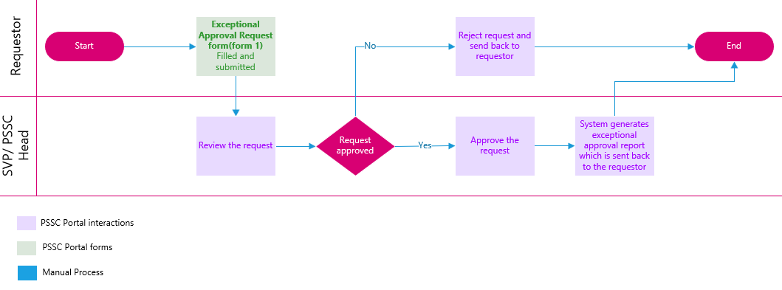

To-be process detailed:

2.5.1

Exception approval request form
Exceptional Approval Digital Form from BU/PSSC
Request Reference Number: * | Auto Generated | System-generated unique ID (read-only)
Business Unit Name* | Dropdown | List of BUs/Departments (fetched from D365)
Brief Description of Purchase/Sale* | Alphanumeric field
Selected Vendor/Buyer Name* | Alphanumeric field
Reason for Approval Request* | Dropdown | - Client/Consultant Approved Vendor / Material  - Exceptional/ Preferred Source Supply (E/PSS)  - Non-Availability of Min 3 Offers When Value > AED 10K  - CC Waiver For Repeated Goods / Or Services For Same Or Other Projects.  - PO To Other Than L1 Vendor  - Emergency Procurement  - Single Source Supply (SSS)  - Finalization Without E-Auction When Value > AED 100k  - Non-Availability of Direct Landlord For Labour Accommodation
Reason Description | Alphanumeric field | Word limit: 2500 words
Reference number* | Alphanumeric field
Contact details of requestor* | Alphanumeric field

DoA*
A | B | C
PSSC | SVP/PSSC Head

Notes:
- There should be an option to push other approved requests (such as insurance or external hire) on the PSSC portal to the Exceptional Approval form.
- Currently, this form can only be raised through other forms when exceptional approval is needed and will not function as a standalone form.
- Export functionality should be available at different stages, showing the current status and approvers.
- Each approver should have the option to approve or reject with comments.
- There should be an option to update the DoA to accommodate business requirements.
2.5.2

Current Challenges
- The current process requires the requestor to complete a manual exceptional approval form, obtain DoA signatures, and email scanned copies.
- There is no centralized tracking; only scanned copies are attached to emails.
- Delays occur due to the need for physical signatures and email approvals from multiple stakeholders, with no SLA tracking in place.
2.5.3

Benefits
- Automation of the current manual forms.
- Improved visibility for all stakeholders throughout the process.
- Centralized tracking of requests with a dashboard showing different request types and SLA breaches.
- Automated notifications to users and requestors about request status.
2.5.4

Automation opportunities
- Smart form linking to pre-fill interconnected forms on the portal, such as e-auction and exceptional approval forms, reducing manual work.
- Development of a backend analytics module to generate periodic insights and exception reports.
- Creation of a central folder system to store main form-linked documents for future reference.

2.6 Chatbot
The chatbot is expected to have the following capabilities:
- User Query Handling
- Respond to user questions typed in natural language (e.g., “What is the status of my request SR-000123?”).
- Understand context-specific queries like:
  - Request Status
  - Process Guidance
  - SLA Information
  - Document Requirements
- Data Retrieval from PSSC Portal
- Connect via API to fetch and display:
  - Request Reference Details
  - Status Updates
  - Submission Date and Approvers
  - SLA Breach Status
  - Attachments or Comments
- Integration with ManageEngine
- Ability to raise tickets on behalf of the user for IT support issues related to the PSSC Portal.
- Fetch and display existing ticket statuses when users provide their ticket reference.
- Auto-acknowledge ticket creation by sharing ticket ID and summary.
- Integration with WhatsApp and teams

- Knowledge Base / FAQ Handling
- Provide responses to common FAQs such as:
  - “How do I submit a request on PSSC?”
  - “What documents are needed for vendor onboarding?”
  - “Whom should I contact for access issues?”
  - Fallback and Escalation
- If the chatbot fails to understand a query, offer:
  - Suggested FAQ topics
  - Escalation to a live agent or email contact form
  - Ticket creation in ManageEngine for further follow-up
- Chat Transcript Logging
- Store user interactions for audit and improvement purposes.
- Provide transcript access to admin users if required.
- User Identification & Personalization
- Recognize logged-in users through Single Sign-On (SSO).
- Personalize greetings and provide user-specific request data.
- 24/7 Availability
- Ensure the chatbot runs 24/7 without manual intervention.

2.7 Landing page of PSSC team(will have requests of PSSC and UVP)
- A landing page has to be developed for the PSSC team, accessible from both the PSSC portal and the UVP.
- The objective is to have a common screen for both UVP and PSSC portals to eliminate the need to switch between two platforms for reviewing or approving requests.

2.8 Common approval process for PSSC and UVP
Current challenge- PSSC/FSSC team uses two portals for approvals
- A standardized and integrated approval workflow has to be implemented across both the PSSC and UVP portals
- This enhancement aims to resolve the current challenge where the PSSC/FSSC team is required to operate within two separate systems to complete approvals.

2.9 Team assignment for the first time login
To streamline user onboarding, an automated setup process will be implemented for first-time login users. Upon initial access to the portal, users will be prompted to complete their team assignment using the following fields
Team Assignment for the first time login
Role* | Dropdown for all teams available in the portal
Business* | Dropdown of all BU’s
Legal Entity* | Dropdown of all Legal entities
Line Manager* | Dropdown of all Line managers in system/ other line managers no in the portal

2.10 SLA Matrix

SLA MATRIX
Request Type | Priority | SLA(Working days) | Default priority setting (Y/N) | SVP/VP Approval requirement (Y/N)
Scrap Sales and De-fleeting(Non-Kabi) | P1 | 14(bifurcation to be defined by Business) | Y | Y
LTPA Creation for Xpedeon | P1 | 2 | Y | N
LTPA amendment/renewal for Xpedeon | P1 | 2 | Y | N
Insurance Sourcing Request | P1 | 14(bifurcation to be defined by Business) | Y | Y
External Hire Request | P1 | 14(bifurcation to be defined by Business) | Y | Y
Exceptional Approval Request | P1 | 2 | Y | Y

Notes:
- The admin should have access to update the SLAs based as per business requirement.

SECTION C: SOW REQUIREMENTS

3.1 Project Plan:
- Provide a timeline and project plan for completing the ERP assessment. Include key milestones and deliverables.

3.2 Team Composition:
- List the proposed team members and their roles.

3.3 RACI Matrix:
- Outline any terms and conditions, such as payment terms, confidentiality agreements, and warranty information.

3.4 Pricing:
- Provide a breakdown of costs, including fees by priority, travel (if applicable), and any additional expenses. Please note P4 Priority items are not part of the scope and are just mentioned for reference. Any work on P4 Priority items shall be documented as separate SOW.

3.5 Payment Terms:
- Outline any terms and conditions, such as payment terms, confidentiality agreements, and warranty information.

SECTION D: SIGNATORIES
Accepted: # Al Ghurair to provide (Yes☐ / No ☐ )
On behalf of Supplier |  | On behalf of Al Ghurair (Client):
Name:  Signature:  Date:  Company Name |  | Name & Signature:  Role:  Date:
Name & Signature:

Role:

Date:
Name & Signature:

Role:

Date:
Name & Signature:

Role:

Date:
Name & Signature:

Role:

Date:

